The promenade access from John Street to Shack Fish & Chips is closed and re-diverted along East Parade Road. Shack Fish & Chips remains open as usual. This closure will be in place until construction work is completed by Autumn 2025. Signage is in place with the clear diversion route. We apologise for any inconvenience this may cause.

Eastbound:

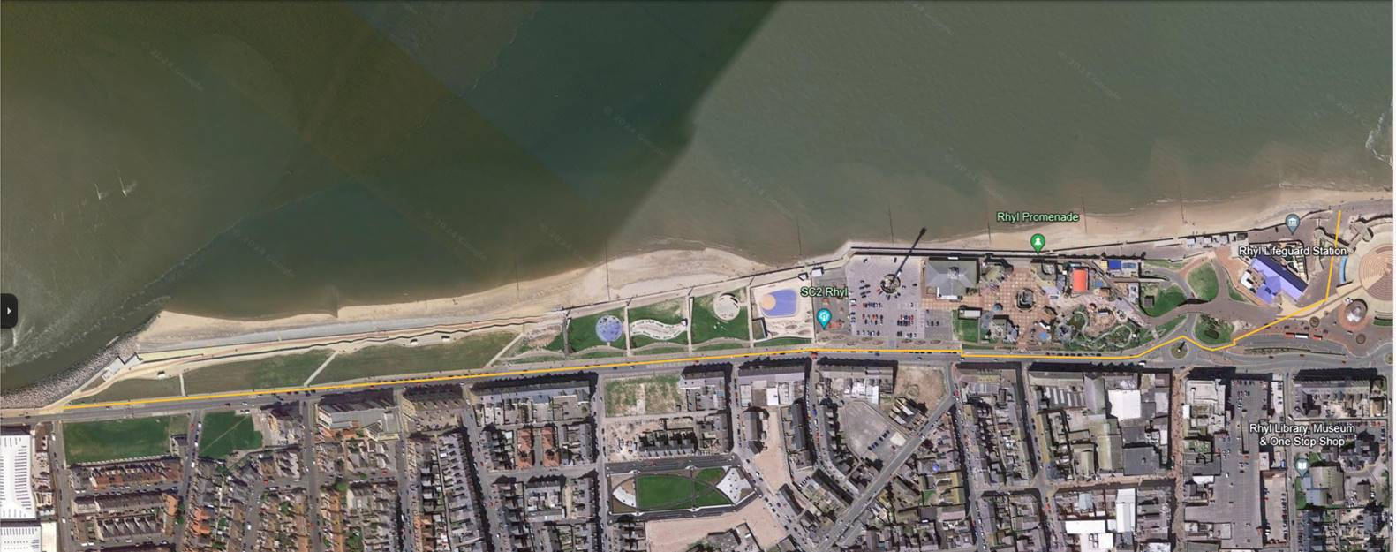

Westbound:

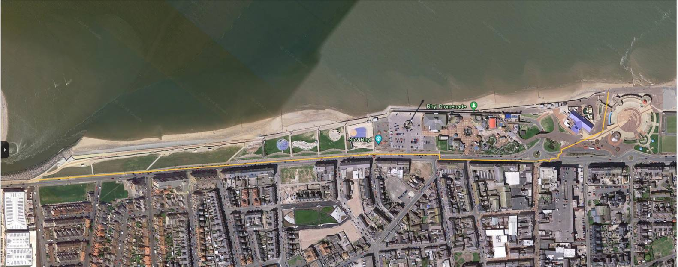

**Temporary Diversion Route**